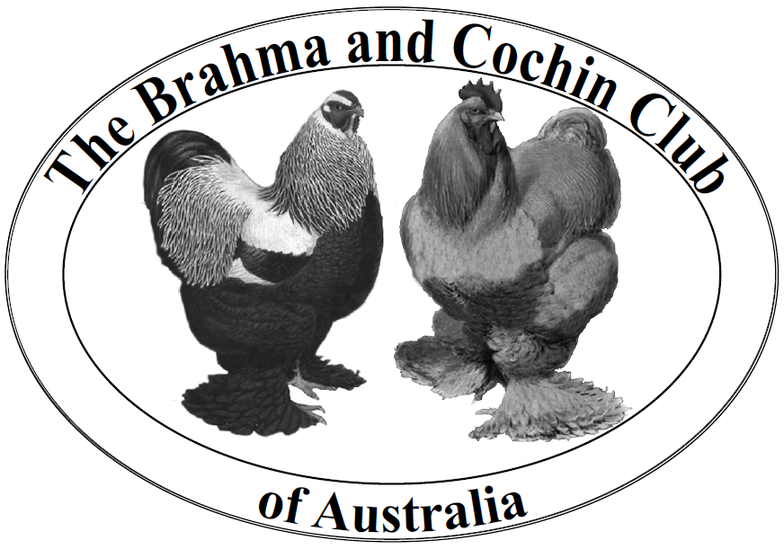
Membership Application Form
The Brahma and Cochin Club of Australia Inc
Reg no A0113812Y
secretary@brahmacochin.org

Membership fees are to be paid by direct deposit. Details below.

OUR MEMBERSHIP YEAR RUNS FROM 1ST JULY – 30th JUNE OF EACH YEAR.  Fees are payable in full. Financial members are eligible for awards at the June long weekend Annual Show and to vote at the July AGM. |  | ☐ INDIVIDUAL MEMBERSHIP - $30  ☐ FAMILY MEMBERSHIP - $30  ☐ JUNIOR MEMBERSHIP (16 YRS AND UNDER) - $10
I/we apply to become a member/members of The Brahma and Cochin Club of Australis. I/we support the purposes of the Club and agree to comply with the Club Rules (see https://tinyurl.com/BCCA-Constitution).
*Name(s):
For family memberships (partners each 17 years or over living in same residence) please provide both names.
*Address:
*State: | *Post Code
*Preferred phone(s): | Other phone(s):
*Email(s):
Would you like to be added to the Breeders Directory on our Club website? YES / NO (please select your response). Please note that the Breeders Directory is updated once a year only in July. New members joining after the annual update will be included in the next scheduled update, where they choose to be so included.
I keep:
☐ Bantam Brahma (list colours)_________________________________________________________
☐ Standard Brahma (list colours)________________________________________________________
☐ Cochin (list colours) ________________________________________________________________
☐ Other breeds kept (please list breeds for which you have a breeding program) ______________________

Please pay by Direct Deposit

Send an email with the completed membership form and online banking payment receipt to secretary@brahmacochin.org or post to
Membership Officer, The Brahma and Cochin Club of Australia c/- PO Box 397 BERRY NSW 2535
Direct Deposit (Bendigo Bank) details:
Account Name: The Brahma Club of Australia BSB: 633-000 Account Number: 1108 9207 2

IMPORTANT – Please use your FULL NAME as the deposit reference so that we can match your payment to your membership application.

.
* Required information. Personal information collected is only for the purposes of Club communications with members. In relation to the Breeders Directory your name, town, phone, email and breeds are made available publicly. Members have the right to request inspection of the Breeders Register at a time and place suitable to the Club. If you have a need to restrict access to your personal information other than by the Committee, please email the Secretary setting out the reasons/circumstances for your request. Requests are treated in strict confidentiality by the Committee.

